
Company
Logotype

Cone Beam Computed Tomography- Report



Porur Dental X-rays & CBCT

Patient Name : Mr. Ramanathan | Date of Report : 26.09.2024
Age/ Gender : 51 years/ Male | Region of Interest : CBCT Full Skull
Referring doctor: Dr. S. Selva Ganesh | Indication : Implant assessment
Clinical Notes: Nil
PATIENT INFORMATION

CBCT- Full Skull provided
CBCT – IMAGE DETAILS

RADIOGRAPHIC INTERPRETATION

- Completely missing crown and root portion in relation to 24, 25, 26, 27, 46, 47.
- Root stumps: 45, 48.
- Hyperdense crown structure present in relation to 11, 12, 13, 14, 15, 16, 17, 21, 22, 23, 31, 32, 33, 34, 35, 36, 37, 38, 41, 42, 43, 44.
- The alveolar ridge in relation to the maxillary and mandibular alveolar ridge is present with resorptive changes leading to reduced height of the mandibular ridges.

IMPLANT ASSESSMENT

 | 24 region
Sub-Crestal | 4
Mid- Crestal | 4.4
Distance between the alveolar ridge and Floor of the Nasal cavity (in mm) | 15.8

 | 25 region | 26 region | 27 region
Sub-Crestal (in mm) | 3.8 | 3.4 | 4.3
Mid- Crestal (in mm) | 4.3 | 4 | -
Distance between the alveolar ridge and floor of the maxillary sinus (in mm) | 15.5 | 10.9 | 6.3

 | 45 region | 46 region | 47 region
Sub-Crestal (in mm) | 4.7 | 3.4 | 7.5
Mid- Crestal (in mm) | 5.9 | 4.7 | 7.7
Distance between alveolar ridge and the inferior alveolar nerve canal (in mm) | - | 12.3 | 10.6
Distance between alveolar ridge and the inferior border of mandible (in mm) | 21.2 | 25.8 | 22

RADIOGRAPHIC IMPRESSION

- Partially edentulous maxillary and mandibular arch.
- Crown in relation to 11, 12, 13, 14, 15, 16, 17, 21, 22, 23, 31, 32, 33, 34, 35, 36, 37, 38, 41, 42, 43, 44.

Kindly correlate with clinical findings


IMAGES FOR REFERENCE

RECONSTRUCTED PANORAMIC VIEW

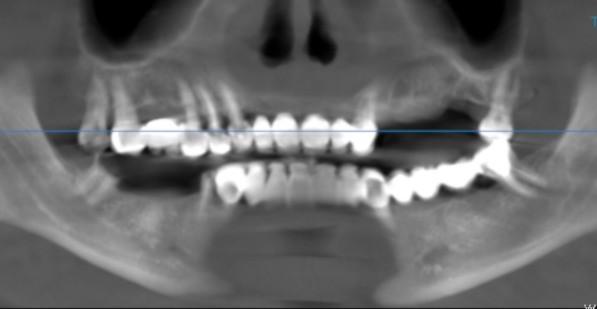

3-DIMENSIONAL VIEW

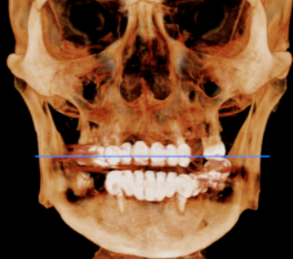

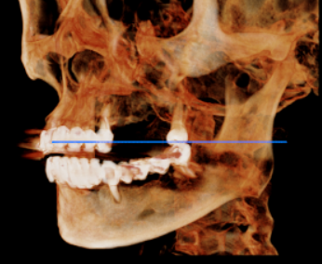
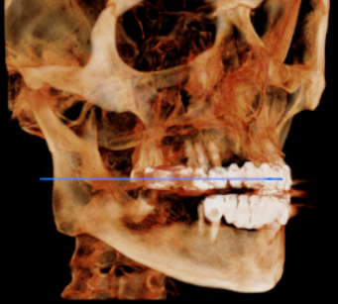

CROSS SECTIONAL VIEW

24 region | 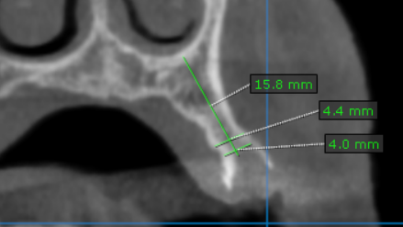
25 region | 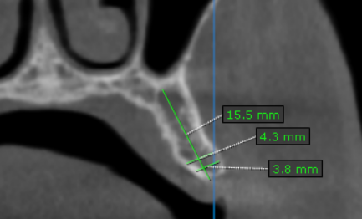
26 region | 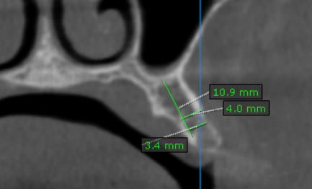
27 region | 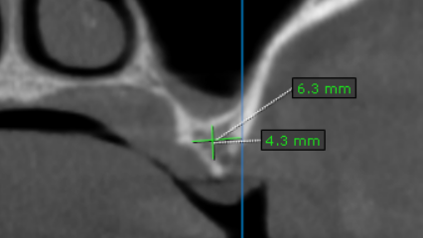
45 region | 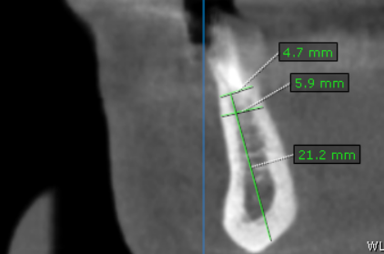
46 region | 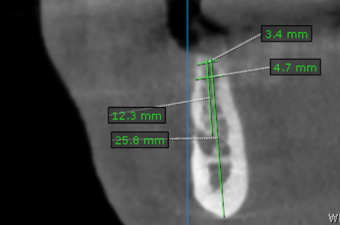
47 region | 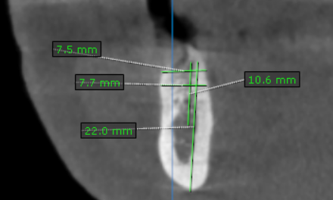

**** End of report ****

